**PART-1**

Step 1 - Create a new maven project

Step 2 - Add maven dependencies

Cucumber Java | Cucumber JUnit | JUnit | Selenium Java

Step 3 - Create a folder Features under src/test/resources

Step 4 - Under features folder create a new feature file login.feature

Step 5- Download cucumber plugin from Eclipse Marketplace

Step 6 Create feature file and add contents

* Feature
* Scenario
* Steps
* Scenario Outline
* Example
* Tags
* Comments

Step 7 - Try to run the feature file

Step 8 - Add Step Definitions / Glue Code under src/test/java package

Step 9 Create a Runner class

Step 10 Create Add Cucumber Options for generating reports

HTML | JSON | JUNIT/XML

Step 11 - Run and verify results

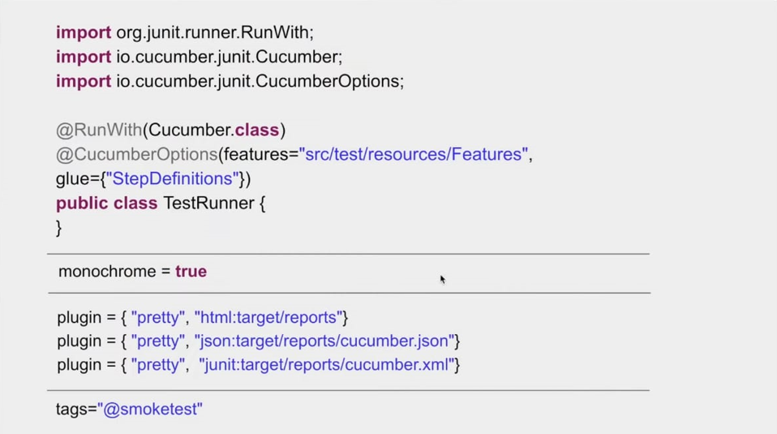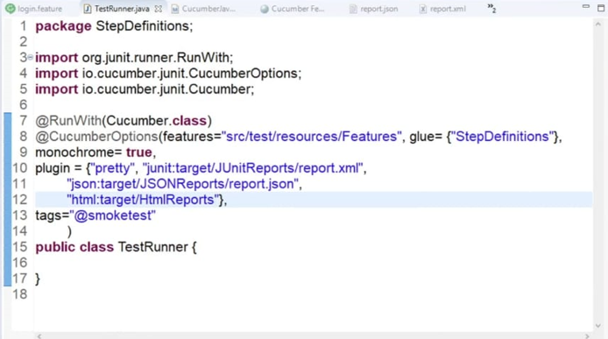

**PART-2**

Step 1 - Add Selenium Java maven dependency

Step 2 - Create a feature file and add Scenario and Steps

Step 3 - Create Step Definition/Glue Code for the steps

Step 4 - Download browser driver files

Step 5 - Add Selenium WebDriver code

Step 6 - Run Feature file and check the execution

**PART 3:**

Parameterization & Data Driven Testing

1. What is parameterization
2. What is data driven testing
3. How to run a feature multiple times with different sets of data

Prerequisites (Completed in earlier session)

1. Project is setup with required maven dependencies (libraries) added
2. A sample login test

**What is parameterization**

1. Open Browser
2. Navigate to login page
3. Enter Admin in username box
4. Enter admin123 in password box
5. Click login button
6. Verify user navigates to Home Page

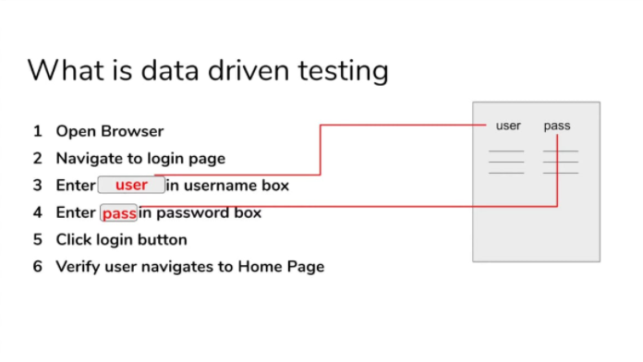

Step 1 - In the feature file select the values that needs to be parameterized

Step 2 - Put the values within conical brackets or double quotes (Parameterization)

Step 3 - Change Scenario to Scenario Outline

Step 4 - Add Examples section

Step 5 - Add data for the parameters in the Examples section

Step 6 - Update step definition to get values from feature file Examples section

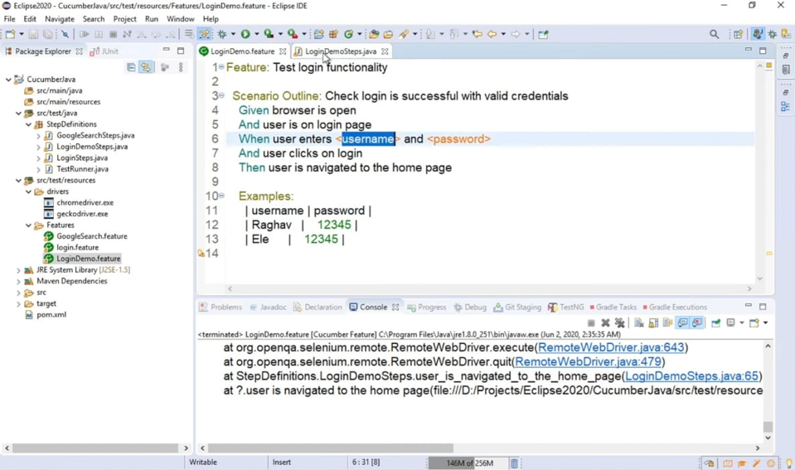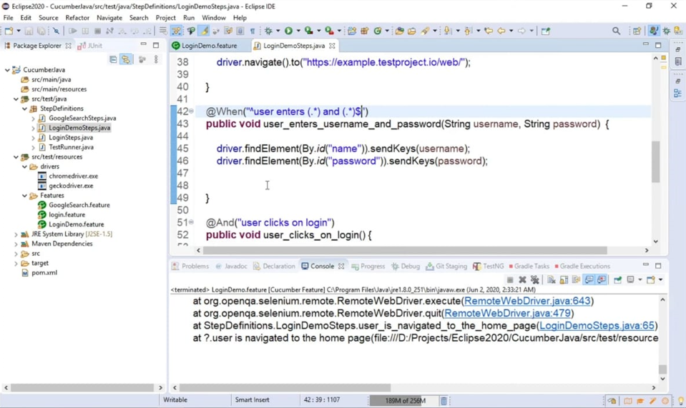

**Page Object Model:**

1- What is POM - Page Object Model

2 - Advantages of POM

3 - How to implement POM in Selenium Cucumber Framework

**Prerequisites:** (Completed in earlier session)

1 - Project is setup with required maven dependencies (libraries) added

2 - A sample login test created

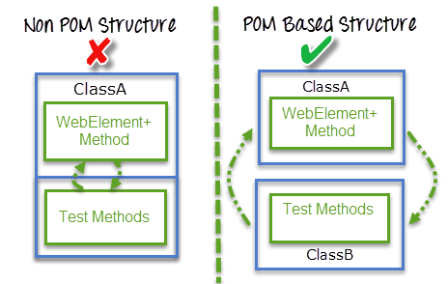

**What is POM?**

Design pattern to create Object Repository

A class is created for each page to identify web elements of that page

Also contains methods to do action on the objects

Separates test objects and test scripts

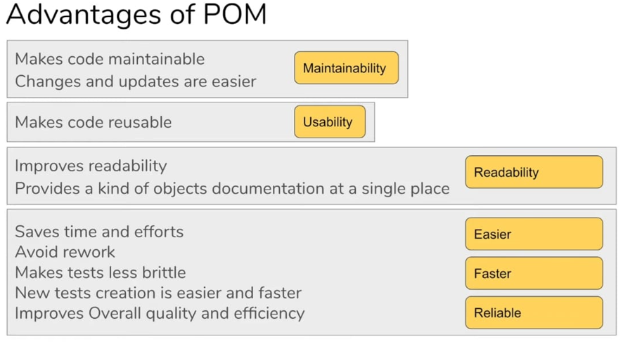

Step 1 - Create a class for each page

Step 2 - Create locators of all objects to be used in that page

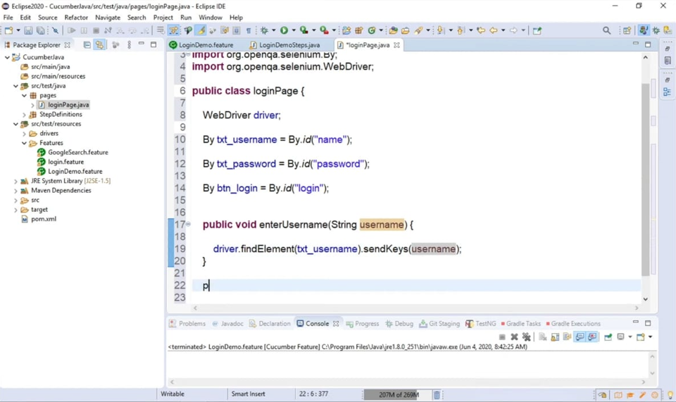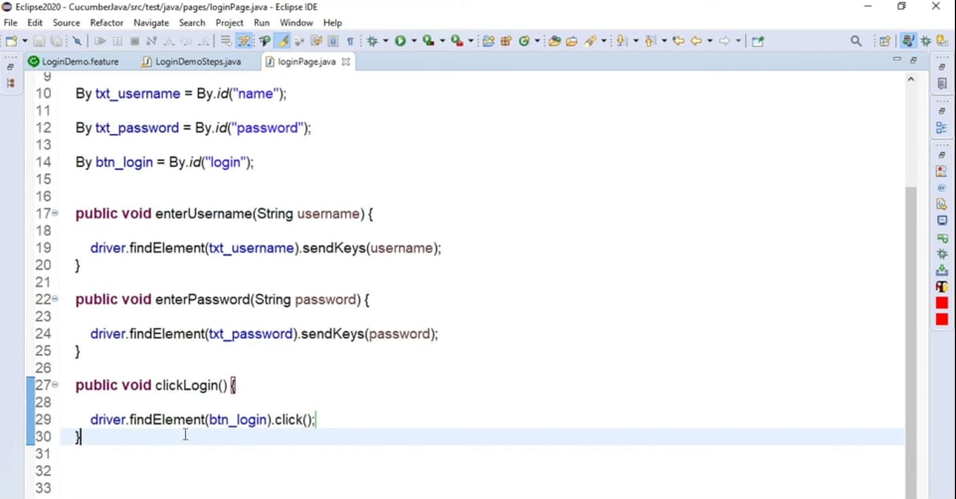

Step 3 - Create methods or actions to be performed on the objects

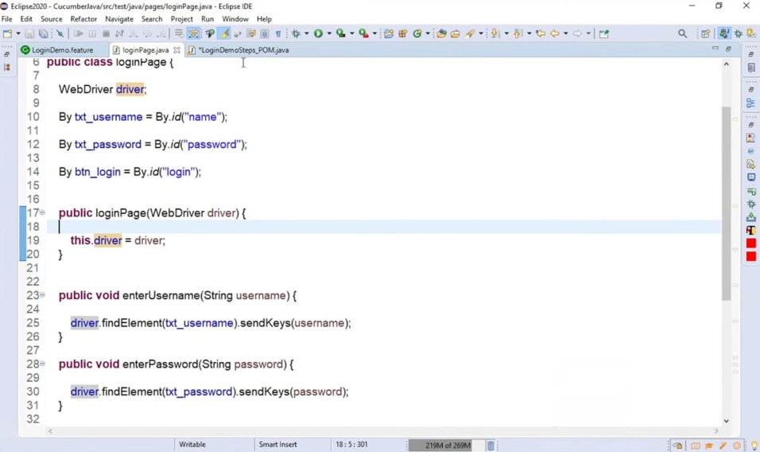Step 4 - Refer in the test scripts

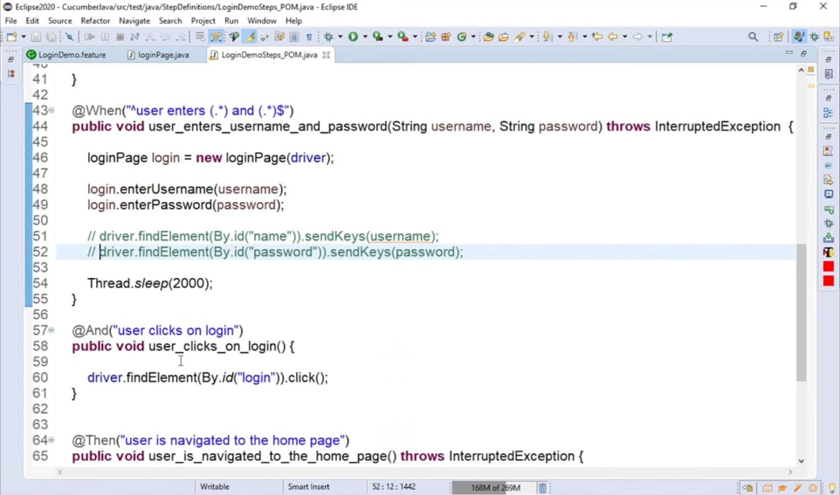Step 5 - Run and validate

**Page Factory:**

1- What is Page Factory

2 - How to implement Page Factory

3 - Useful Tips

**Page Factory:**

A simple and easier implementation of Page Object Model in Selenium

Selenium's inbuilt and optimized Page Object Model concept

As POM, has separation of objects and tests

Uses annotation @FindBy to find WebElements

@FindBy can use id, name, css, xpath, tagName, linkText, partial LinkText etc

Uses method initElements to initialize web elements

on calling initElements method all objects on that page gets initialized

Step 1 - Create a class for each page

Step 2 - Create locators of all objects to be used in that page using @FindBy

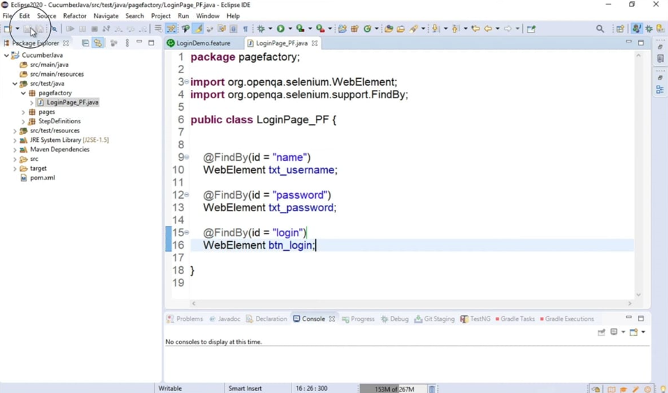 Step 3 - Create methods or actions to be performed on the objects

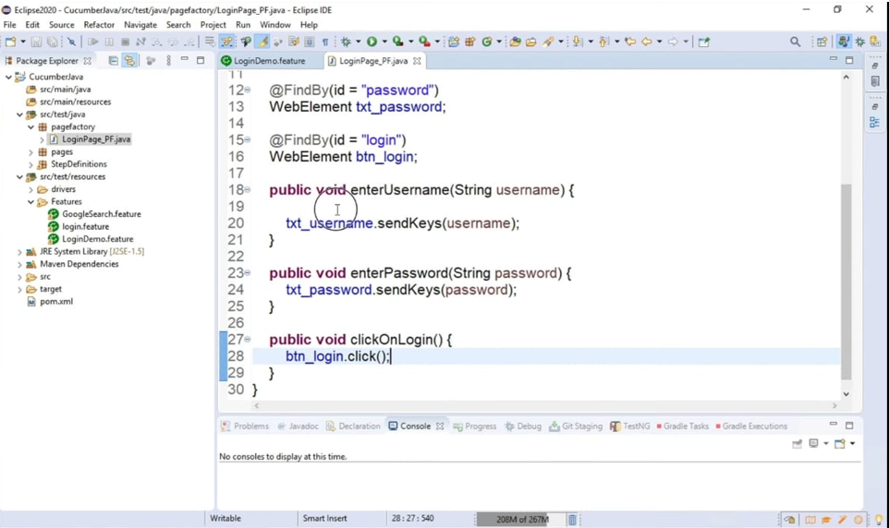

Step 4 - Create constructor to get driver instance and initialize Elements using method initElements

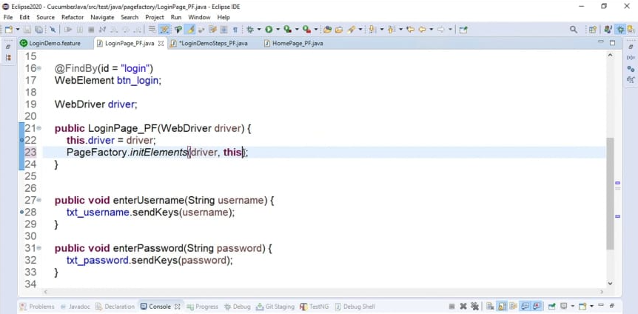 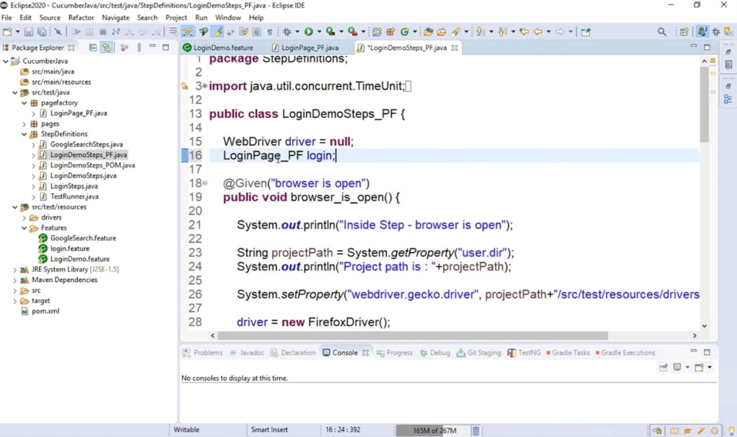 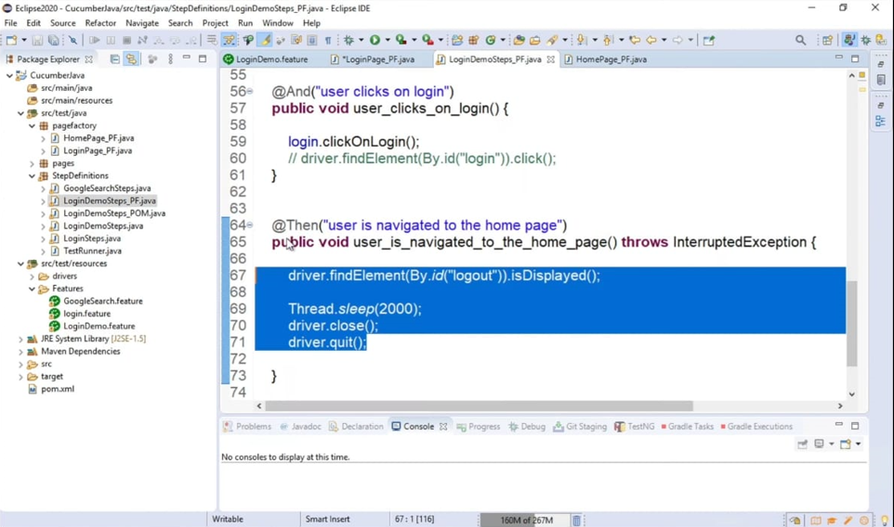

Step 5 - Update Test Scripts to refer methods from PageFactory class

Step 6 - Run and validate

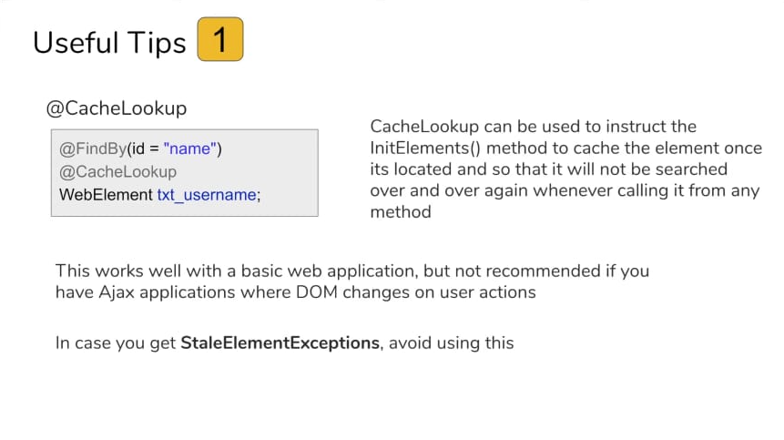 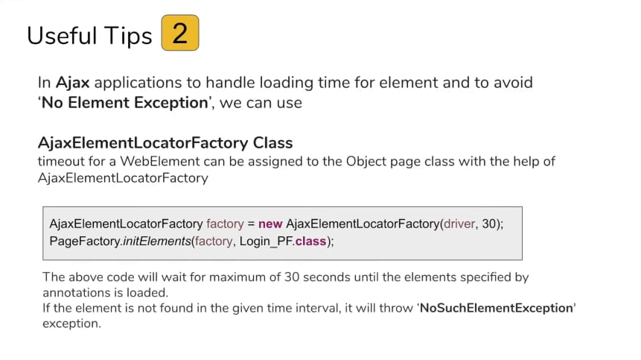 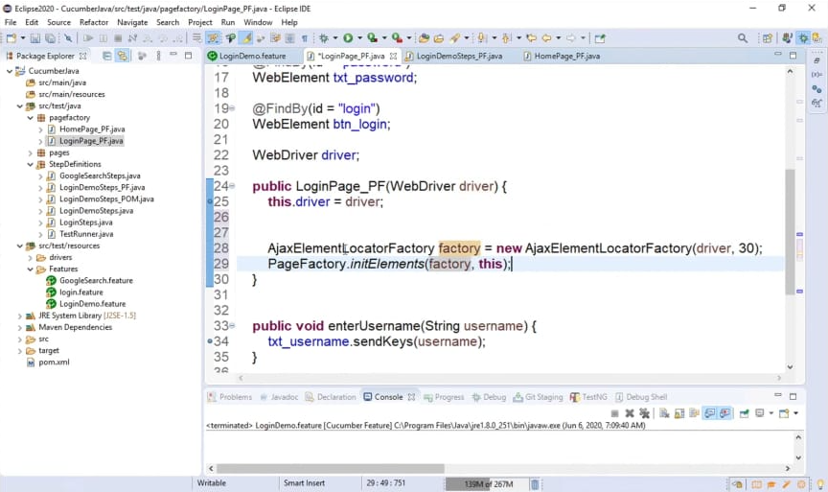 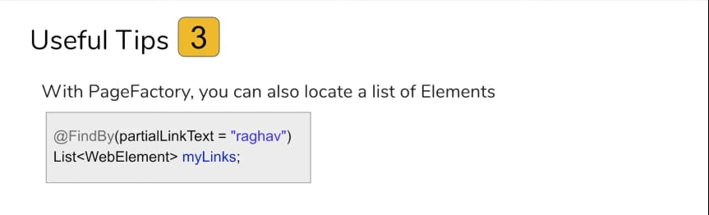 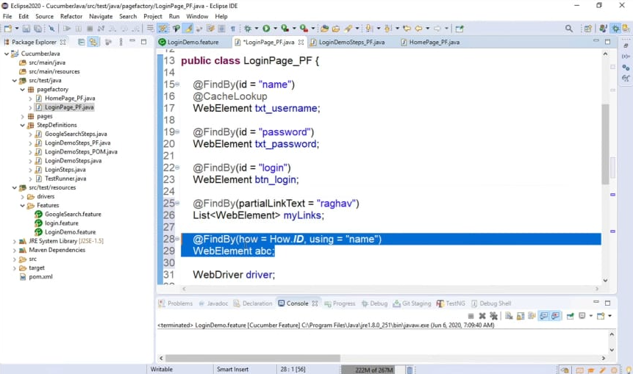

**Tags:**

1- What are Tags

2 - How to use Tags (Demo)

3- Useful Tips

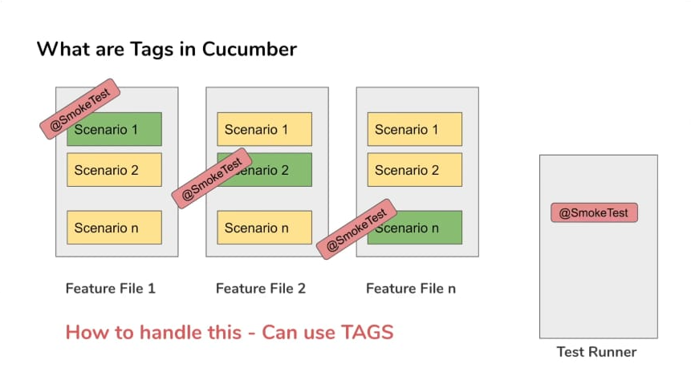 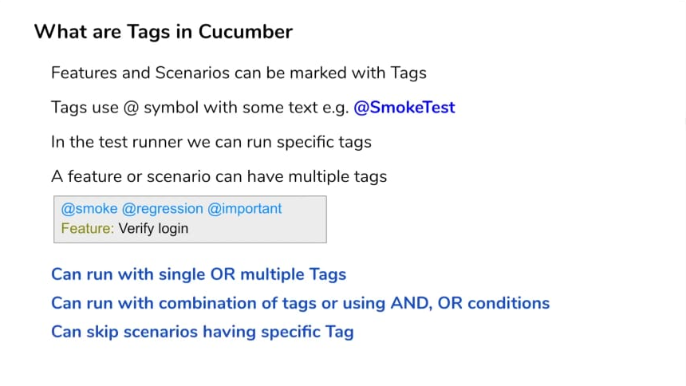

Step 1 - Create a new or use an existing Feature File

Step 2 - Mark the feature and scenarios with Tags : @TagName

Step 3 - Create new or use an existing TestRunner class

Step 4 - Add the tags in CucumberOptions section 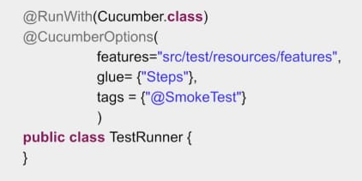

Step 5 - Run test runner class with different combination of tags 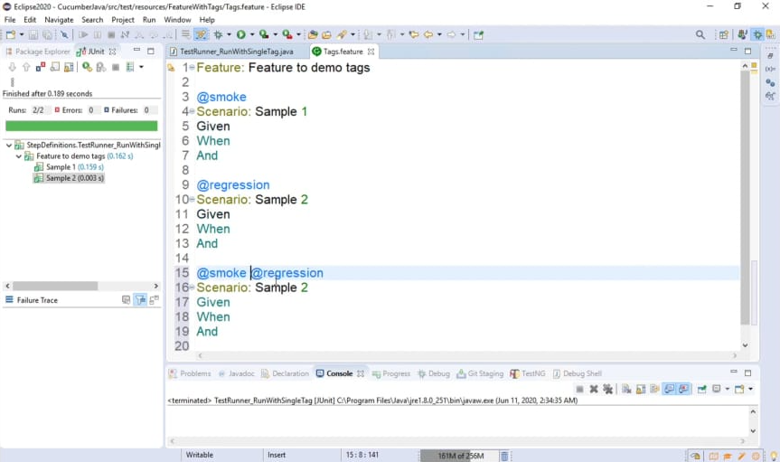 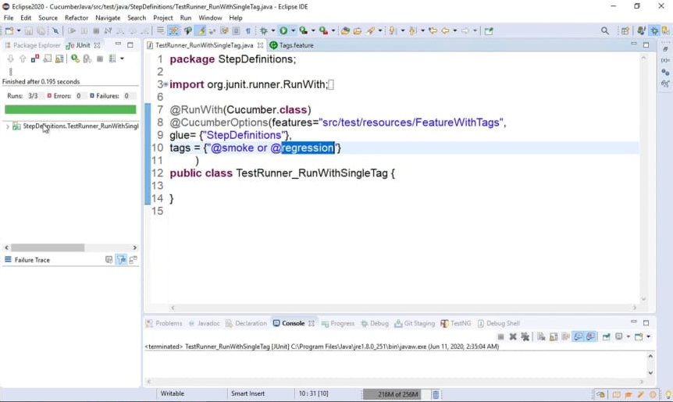 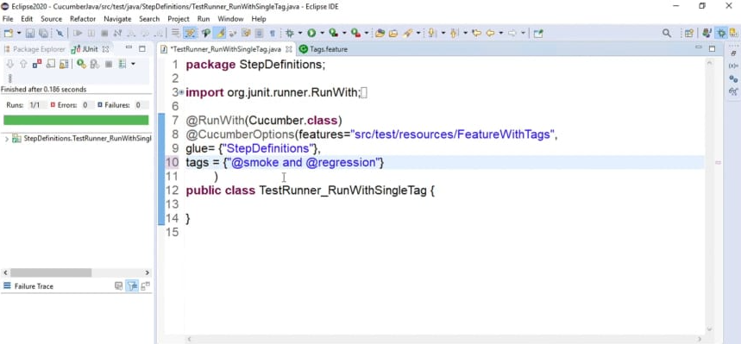 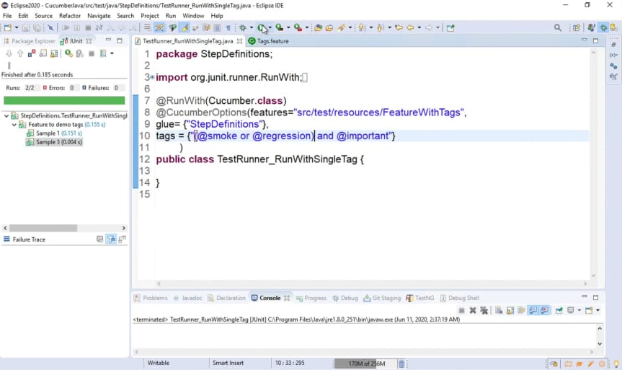 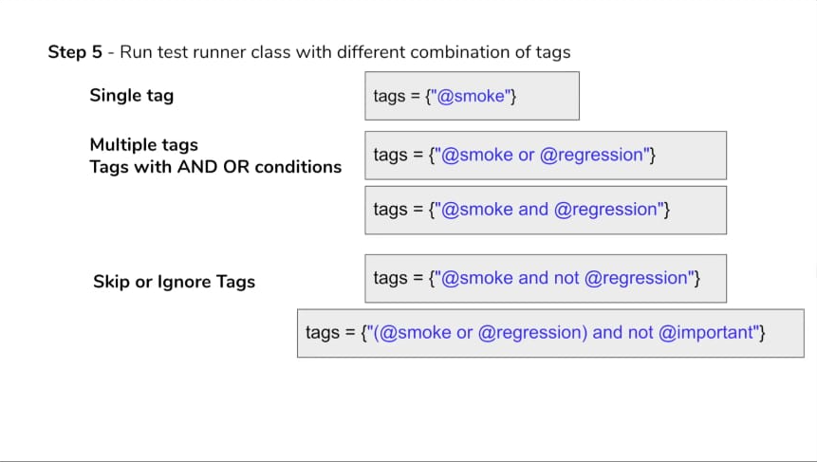 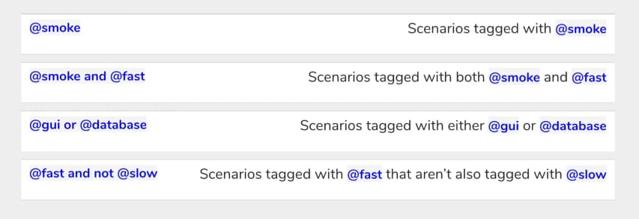

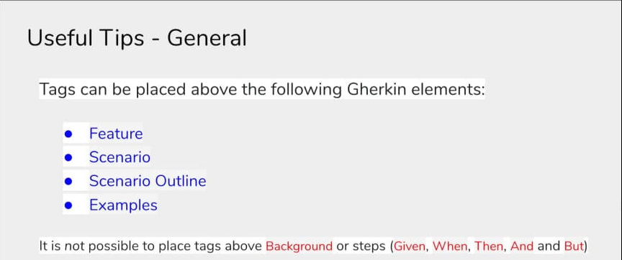

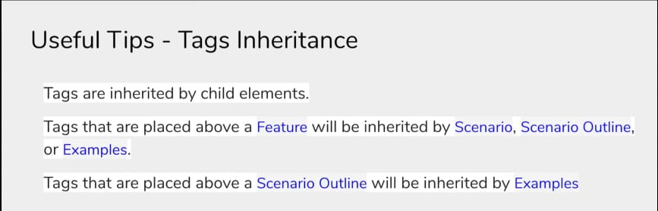

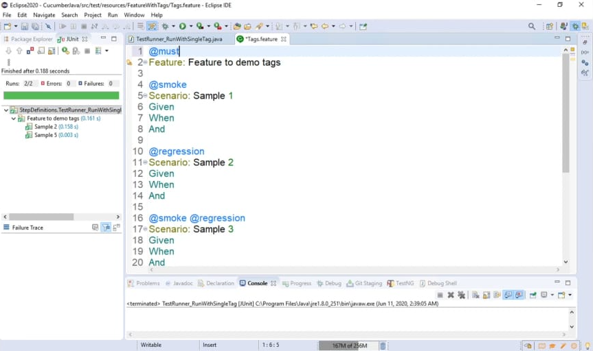

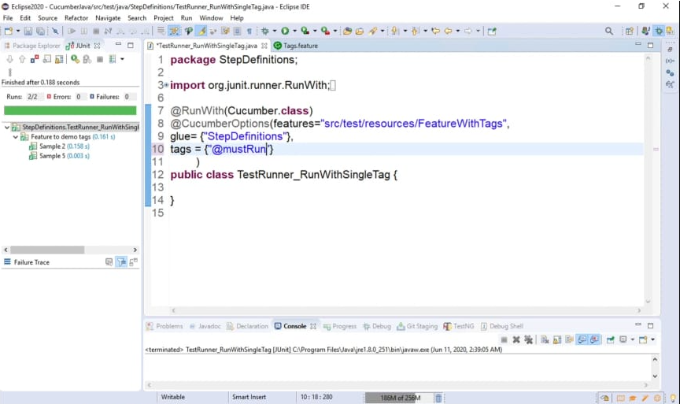

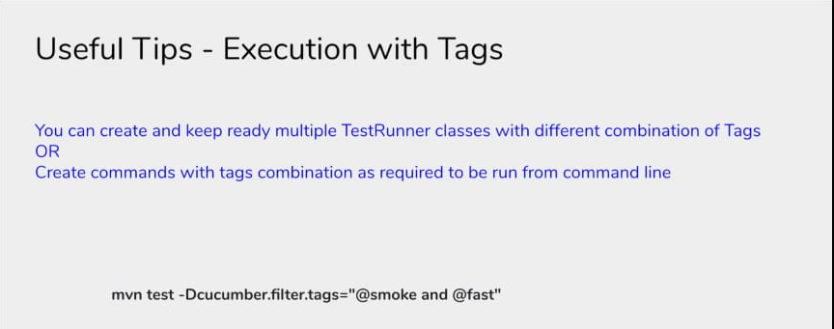

**Hooks:**

1- What are Hooks

2 - Why to use Hooks

3- When to use Hooks

4 - How to create & use Hooks - Step by Step Demo

5- Conditional Hooks

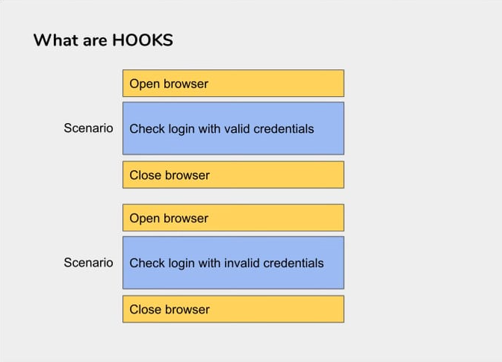 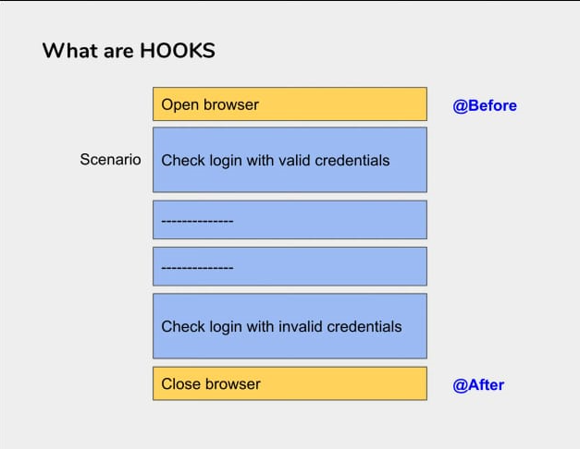

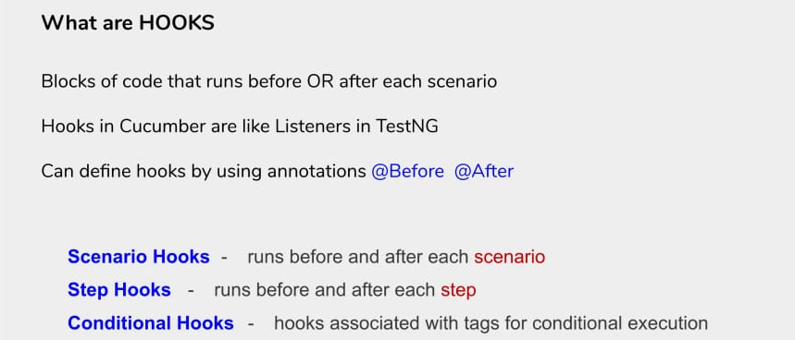

**Why to use HOOKS:**

* To manage the setup and teardown
* To avoid rewriting the common setup or teardown actions
* Allow better management of code workflow

**When to use HOOKS:**

* Whenever you have some common setup and teardown actions to be executed before each scenario

**How to use HOOKS:**

Step 1 - Create a new or use an existing Feature File

Step 2 - Create the steps for the scenario in the feature file

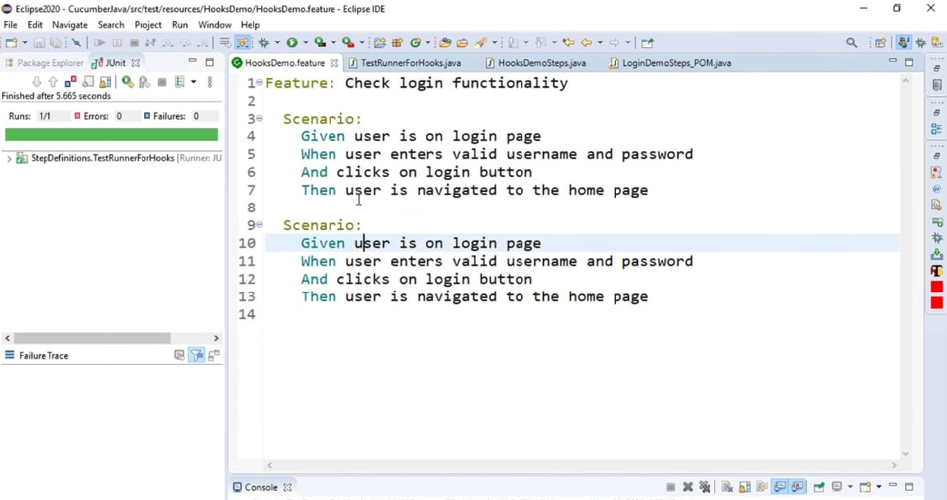

Step 3 - Create setup and teardown methods and mark with annotation

@Before @BeforeSteps

@After @AfterSteps

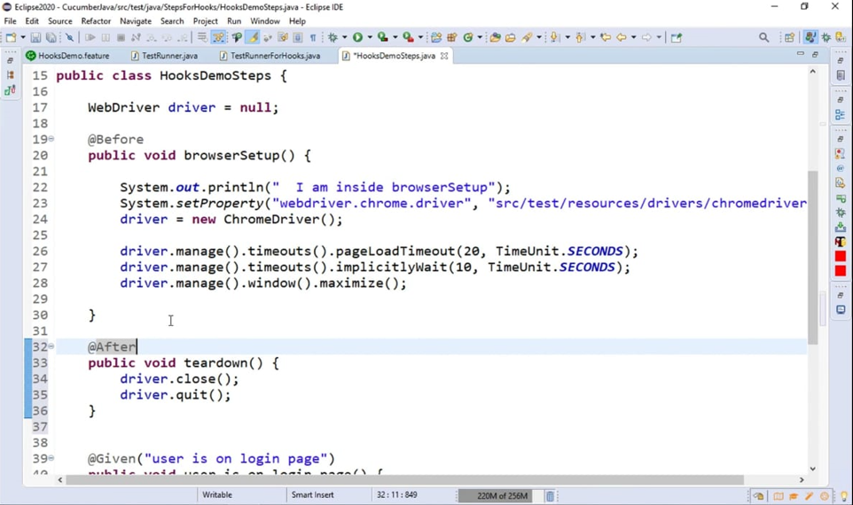

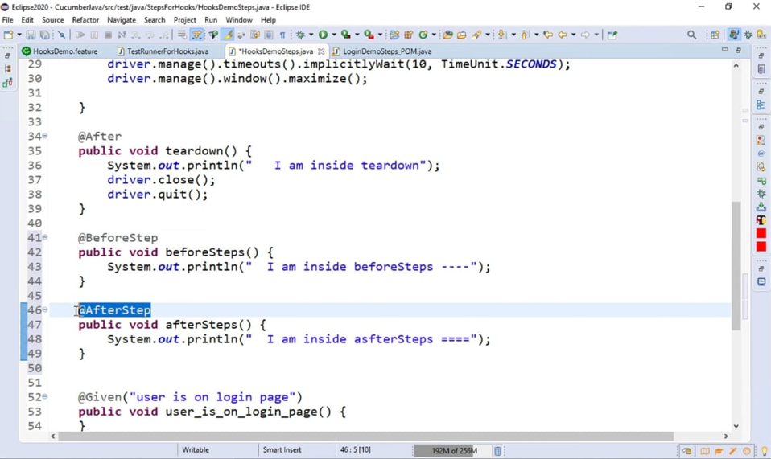

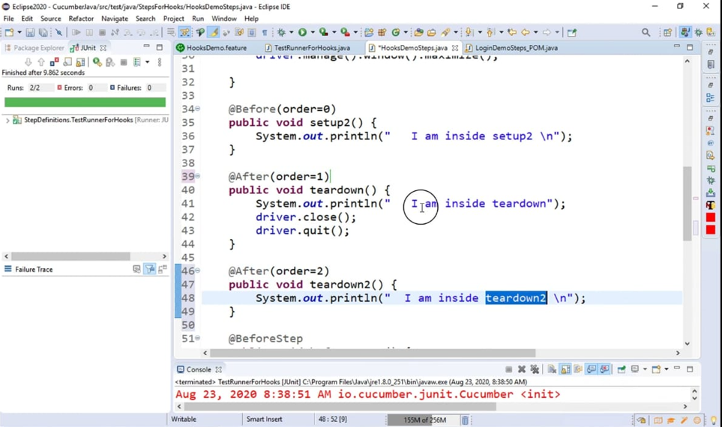

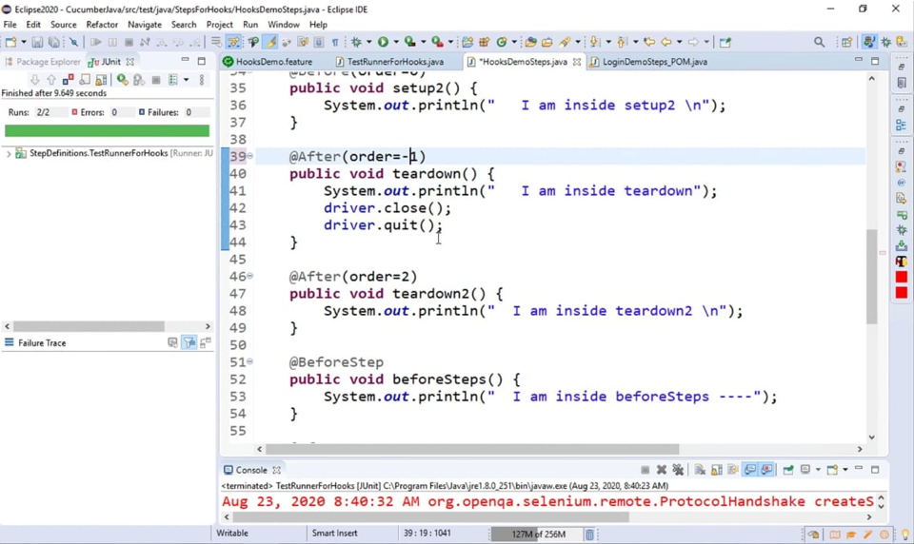

Step 4 - Create new or use an existing TestRunner class

Step 5 - Run the TestRunner class and check execution

**Conditional Hooks:**

Hooks can be conditionally selected for execution based on the tags of the scenario

To run a particular hook only for certain scenarios, you can associate a Before or After hook with a tag expression

Tags can be used with

@Before @BeforeSteps

@After @AfterSteps

@After(value="@smoke", order=2)

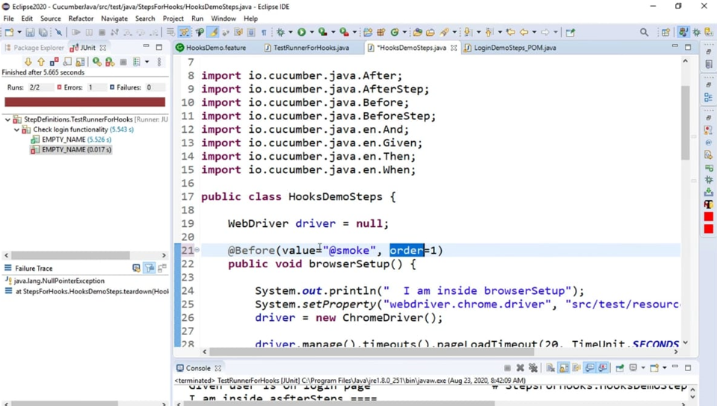

Useful TIPS -1

**Ordering Hook**

We can use multiple Before and After hooks and also assign order of execution

@Before(order=0)

@Before(order=1)

Useful TIPS -2

**Background**

* Whatever happens in hooks is invisible to people who only read the features
* Only use hooks for low-level logic such as starting a browser or deleting data from a database.
* You should consider using a background as a more explicit alternative, especially if the setup should be readable by non-technical people

Useful TIPS -3

* You can keep your function name anything
* Hooks will get executed even if the test fails
* You need to import the library

import io.cucumber.java.Before;

import io.cucumber.java.After;

**Background:**

1- What is Background

2- Why to use Background

3- When to use Background

4 - How to create & use Background

**What is Background:**

* A Step or a group of steps that are common to all the scenarios in a feature Is defined once in the feature
* Runs before every scenario of the feature

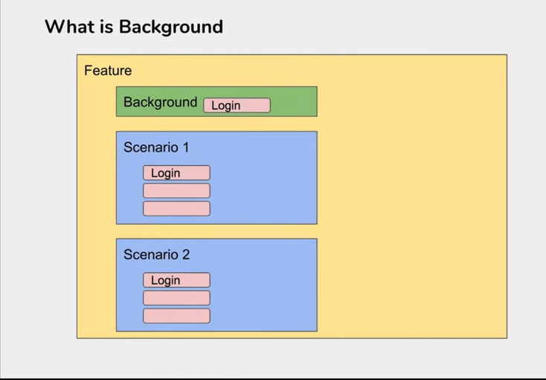

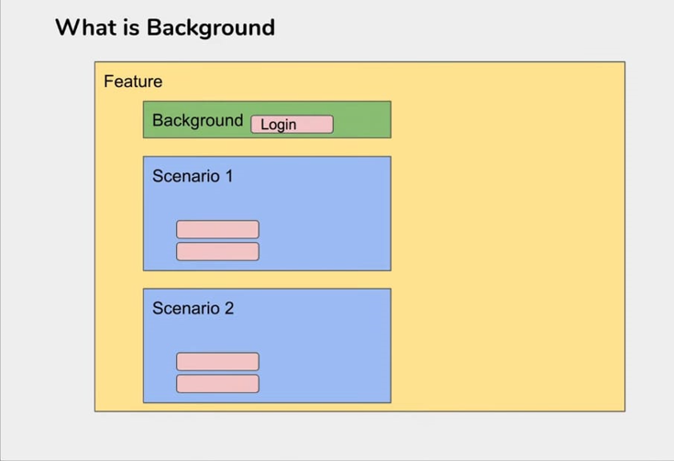

**Why to use Background**

* To avoid repeating the common steps in every scenario
* For better readability & maintenance
* Unlike hooks, background is visible to the readers of the feature file

**When to use Background:**

* Whenever there are common repeating steps in a feature
* When you want the common steps to be visible to the readers

**How to use Background:**

Step 1 - Create a new or use an existing Feature File

Step 2 - Create the steps for the scenario in the feature file

Step 3 - Create new or use an existing Test Runner class

Step 4 - Run the test runner file

Step 5 - Create a background section and add common steps

Step 6 - Run the test runner file and check execution of background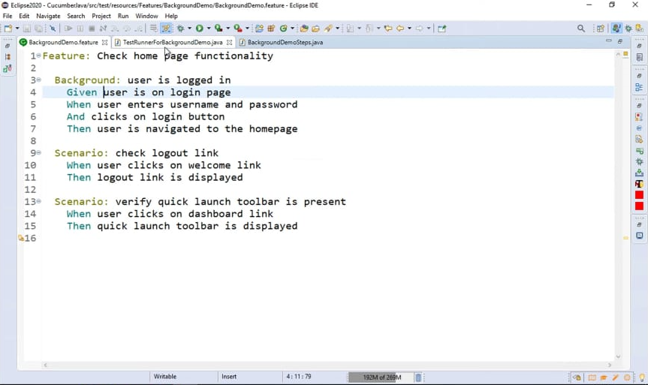

**Useful TIPS-1;**

* You can only have one set of Background steps per Feature.
* If you need different Background steps for different scenarios, consider breaking up your set of scenarios into more Features.
* Use background so that all stakeholders can understand the scenario